Monitoring Cassandra
Understanding the performance characteristics of a Cassandra cluster is critical to diagnosing issues and planning capacity. Use DataStax tools and a Java Console (JConsole) to get node and cluster statistics.

Cassandra exposes a number of statistics and management operations via Java Management Extensions (JMX). JMX is a Java technology that supplies tools for managing and monitoring Java applications and services. Any statistic or operation that a Java application has exposed as an MBean can then be monitored or manipulated using JMX.
JMX). JMX is a Java technology that supplies tools for managing and monitoring Java applications and services. Any statistic or operation that a Java application has exposed as an MBean can then be monitored or manipulated using JMX.
During normal operation, Cassandra outputs information and statistics that you can monitor using JMX-compliant tools, such as:
- The Cassandra nodetool utility
- nodetool sjk
- Using JConsole
Using the same tools, you can perform certain administrative commands and operations such as flushing caches or doing a node repair.
The nodetool utility is a command-line interface for monitoring a cluster and performing routine database operations. It is typically run from an operational node.
The nodetool utility provides commands for viewing detailed metrics for tables, server metrics, and compaction statistics:
- nodetool tablestats displays statistics for each table and keyspace.
- nodetool tablehistograms provides statistics about a table, including read/write latency, row size, column count, and number of SSTables.
- nodetool netstats provides statistics about network operations and connections.
- nodetool tpstats provides statistics about the number of active, pending, and completed tasks for each stage of database operations by thread pool.
This example shows the output from nodetool proxyhistograms after running 4,500 insert statements and 45,000 select statements on a three ccm node-cluster on a local computer.
nodetool proxyhistograms
proxy histograms
Percentile Read Latency Write Latency Range Latency
(micros) (micros) (micros)
50% 1502.50 375.00 446.00
75% 1714.75 420.00 498.00
95% 31210.25 507.00 800.20
98% 36365.00 577.36 948.40
99% 36365.00 740.60 1024.39
Min 616.00 230.00 311.00
Max 36365.00 55726.00 59247.00
JConsole is a JMX-compliant tool for monitoring Java applications. JConsole is included with Sun JDK 5.0 and later. JConsole consumes the JMX metrics and operations exposed by DataStax Enterprise and displays them in a well-organized GUI. For each node monitored, JConsole provides these six separate tab views:
Overview
Displays overview information about the Java VM and monitored values.
Memory
Displays information about memory use.
Threads
Displays information about thread use.
Classes
Displays information about class loading.
VM Summary
Displays information about the Java Virtual Machine (VM).
Mbeans
Displays information about MBeans.
The Overview and Memory tabs contain information that is very useful for developers. The Memory tab allows you to compare heap and non-heap memory usage, and provides a control to immediately perform Java garbage collection.
For specific database metrics and operations, the most important area of JConsole is the MBeans tab. This tab lists the following MBeans:
org.apache.cassandra.auth
Includes permissions cache.
org.apache.cassandra.db
Includes caching, table metrics, and compaction.
org.apache.cassandra.internal
Internal server operations such as gossip, hinted handoff, and Memtable values.
org.apache.cassandra.metrics
Includes metrics on CQL, clients, keyspaces, read repair, storage, threadpools, and other topics.
org.apache.cassandra.net
Inter-node communication including FailureDetector, MessagingService, and StreamingManager.
org.apache.cassandra.request
Tasks related to read, write, and replication operations.
org.apache.cassandra.service
Includes GCInspector.
When you select an MBean in the tree, its MBeanInfo and MBean Descriptor are displayed on the right, and any attributes, operations or notifications appear in the tree below it. For example, selecting and expanding the org.apache.cassandra.db MBean to view available actions for a table results in a display like the following:

If you choose to monitor DataStax Enterprise using JConsole, keep in mind that JConsole consumes a significant amount of system resources. For this reason, DataStax recommends running JConsole on a remote machine rather than on the same host as a DataStax Enterprise node.
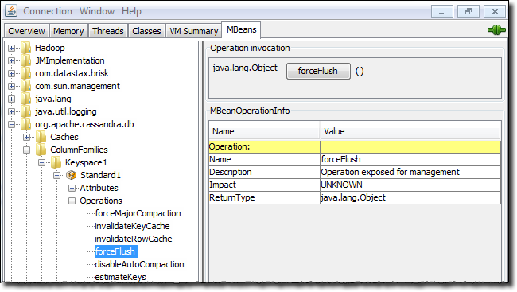
The JConsole CompactionManagerMBean exposes compaction metrics that can indicate when you need to add capacity to your cluster.
To get values from the command line, first get the complete name of the MBean.
Following is an example of how to use jmxterm to dump the full list of JMX MBeans from a database node:
echo "beans" | java -jar jmxterm-1.0.0-uber.jar -l localhost:7199 -n 2>&1
Tip: Only perform this operation once because the list can be large or search MBeans with particular names in the output by redirecting the result to another filter. For example to find MBeans that contain the word commitlog:
echo "beans" | java -jar /tmp/jmxterm-1.0.0-uber.jar -l localhost:7199 -n 2>&1 | grep -i commitlog
The results provide the exact MBean strings to use in nodetool sjk mx command.
com.datastax.bdp.advrep.v2.metrics:name=CommitLogMessagesRead,type=ReplicationLog
com.datastax.bdp.advrep.v2.metrics:name=CommitLogsDeleted,type=ReplicationLog
com.datastax.bdp.advrep.v2.metrics:name=CommitLogsToConsume,type=ReplicationLog
org.apache.cassandra.db:type=Commitlog
org.apache.cassandra.metrics:name=CompletedTasks,type=CommitLog
org.apache.cassandra.metrics:name=PendingTasks,type=CommitLog
org.apache.cassandra.metrics:name=TotalCommitLogSize,type=CommitLog
org.apache.cassandra.metrics:name=WaitingOnCommit,type=CommitLog
org.apache.cassandra.metrics:name=WaitingOnSegmentAllocation,type=CommitLog
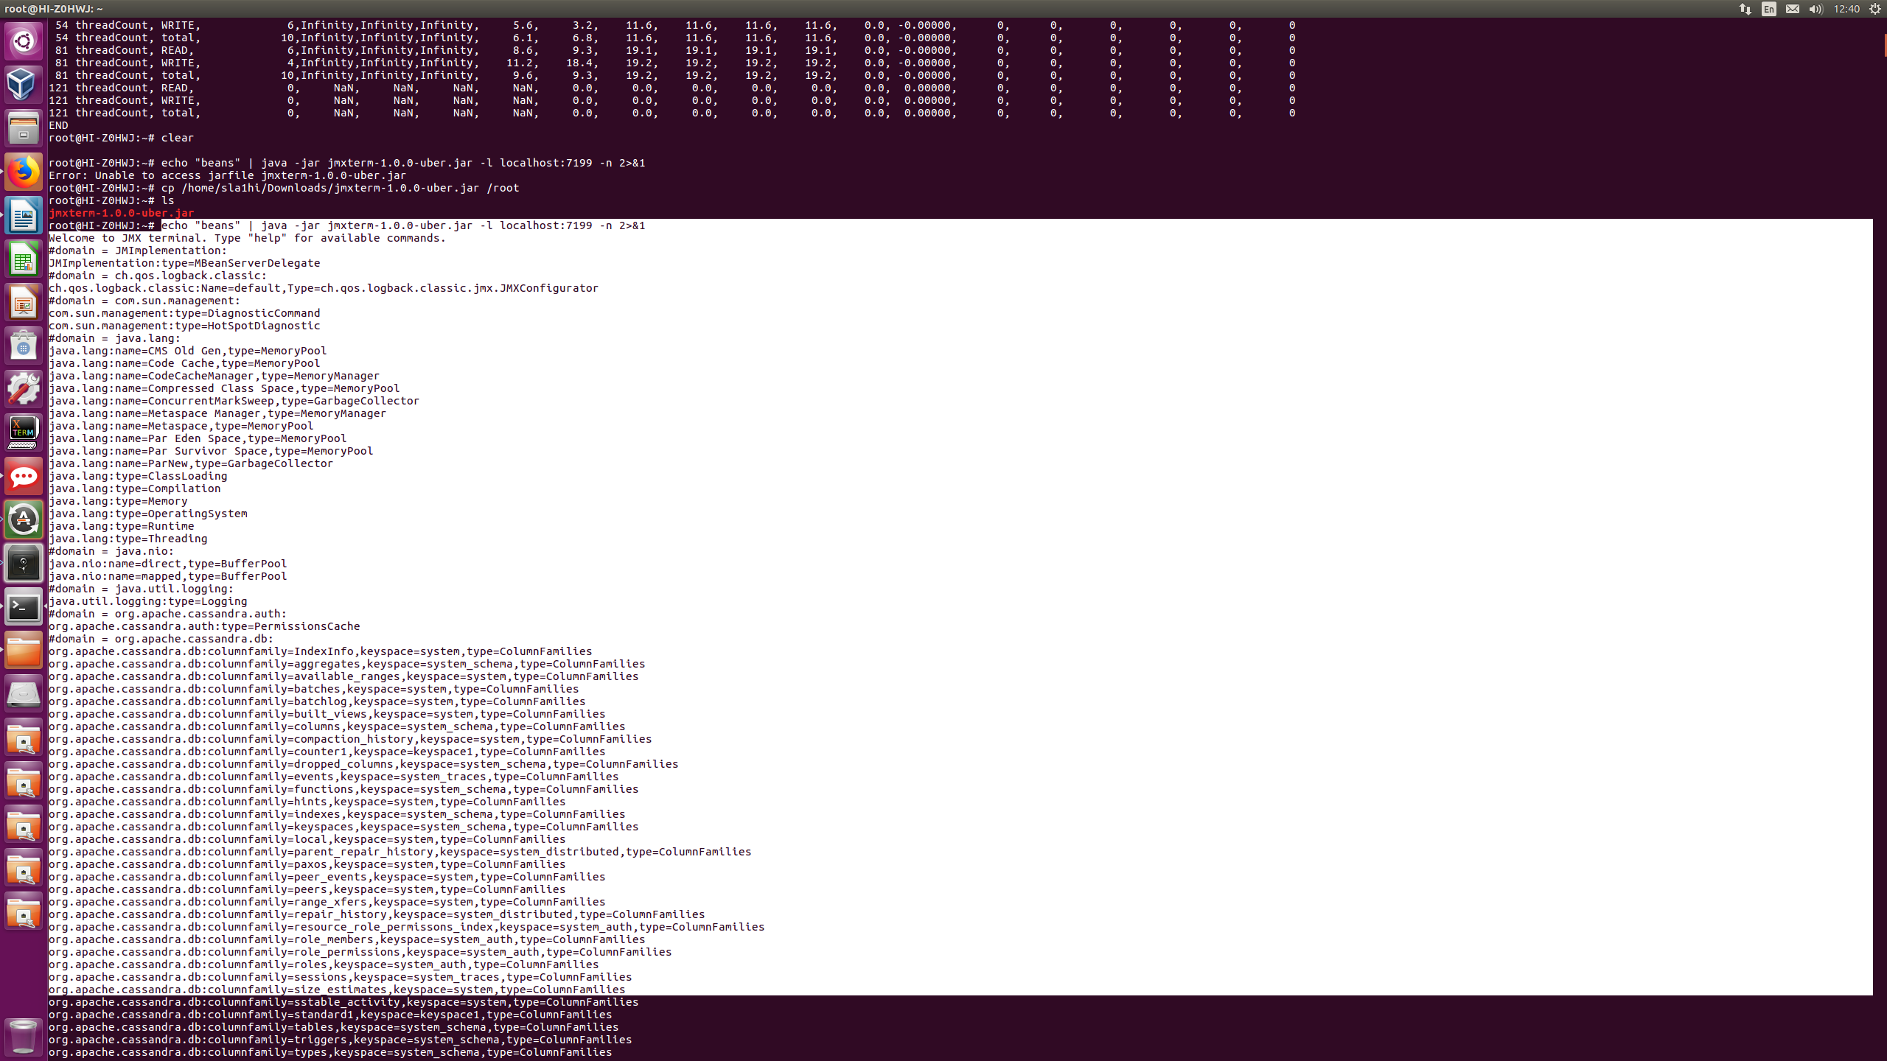
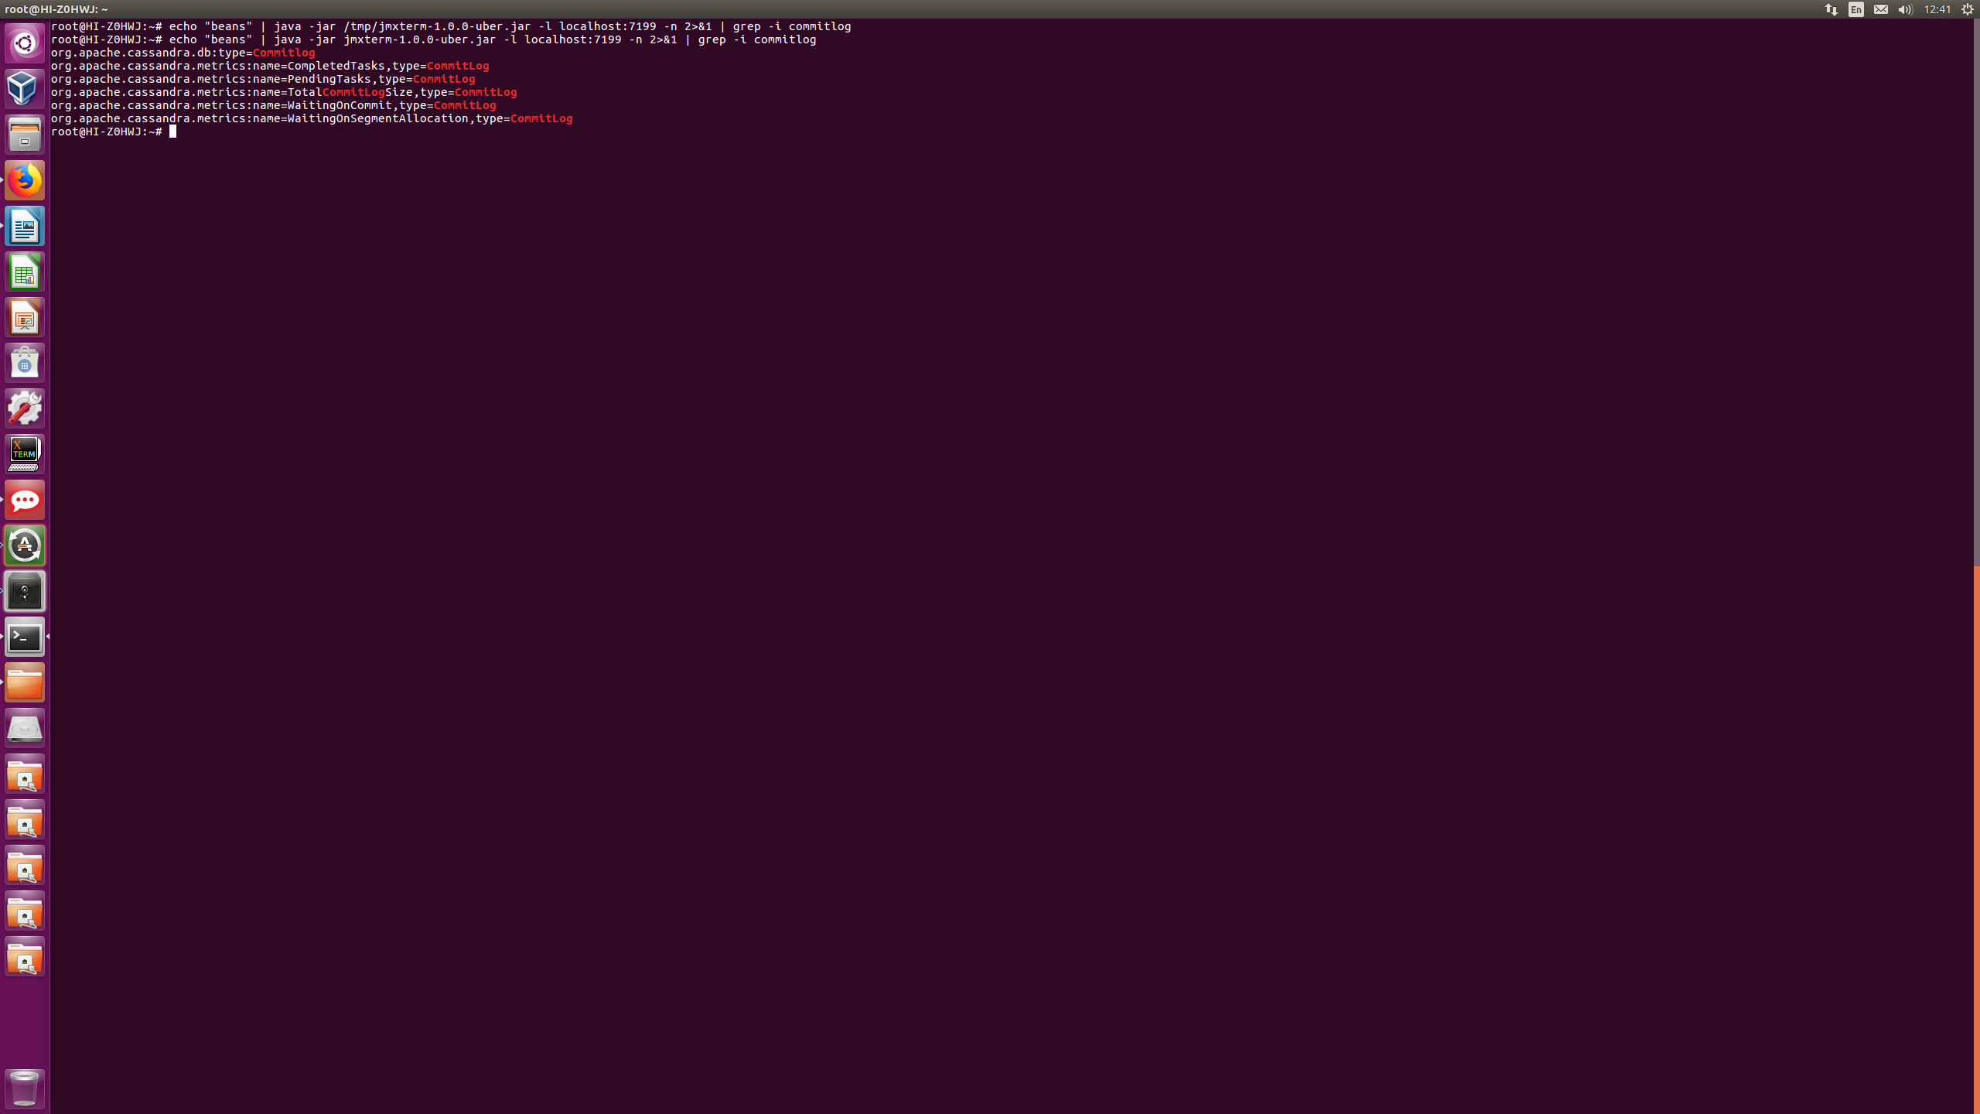

Getting the MBean options and values
Use the MBean information option to show available values. For example, to show the options available for TotalCommitLogSize from the previous results, use the complete name:
nodetool sjk mx -b "org.apache.cassandra.metrics:name=TotalCommitLogSize,type=CommitLog" -mi
org.apache.cassandra.metrics:type=CommitLog,name=TotalCommitLogSize
org.apache.cassandra.metrics.CassandraMetricsRegistry$JmxGauge
- Information on the management interface of the MBean
(A) Value : java.lang.Object
- Attribute exposed for management
(O) objectName() : javax.management.ObjectName
- Operation exposed for management
The MBean has a simple value. To read the single number, run the following command:
nodetool sjk mx -b "org.apache.cassandra.metrics:name=TotalCommitLogSize,type=CommitLog" -f Value -mg
org.apache.cassandra.metrics:type=CommitLog,name=TotalCommitLogSize
67108864
Note: SJK is case-sensitive, enter the names exactly.
To check on a more complex metric such as latency, find out how many values are available by using -mi option:
nodetool sjk mx -b "org.apache.cassandra.metrics:name=Latency,scope=Read,type=ClientRequest" -mi
org.apache.cassandra.metrics:type=ClientRequest,scope=Read,name=Latency
org.apache.cassandra.metrics.CassandraMetricsRegistry$JmxTimer
- Information on the management interface of the MBean
(A) Max : double
- Attribute exposed for management
(A) Min : double
- Attribute exposed for management
(A) Mean : double
- Attribute exposed for management
(A) StdDev : double
- Attribute exposed for management
(A) 95thPercentile : double
- Attribute exposed for management
(A) DurationUnit : String
- Attribute exposed for management
(A) 50thPercentile : double
- Attribute exposed for management
(A) 75thPercentile : double
- Attribute exposed for management
(A) 98thPercentile : double
- Attribute exposed for management
(A) 99thPercentile : double
- Attribute exposed for management
(A) 999thPercentile : double
- Attribute exposed for management
(A) OneMinuteRate : double
- Attribute exposed for management
(A) FifteenMinuteRate : double
- Attribute exposed for management
(A) FiveMinuteRate : double
- Attribute exposed for management
(A) MeanRate : double
- Attribute exposed for management
(A) RateUnit : String
- Attribute exposed for management
(A) Count : long
- Attribute exposed for management
(O) values() : long[]
- Operation exposed for management
(O) objectName() : javax.management.ObjectName
- Operation exposed for management
Then to read out a single value from this metric, use the following command:
nodetool sjk mx -b "org.apache.cassandra.metrics:name=Latency,scope=Read,type=ClientRequest" -f 99thPercentile -mg
org.apache.cassandra.metrics:type=ClientRequest,scope=Read,name=Latency
3379.391

Table statistics
For individual tables, ColumnFamilyStoreMBean provides the same general latency attributes as StorageProxyMBean. Unlike StorageProxyMBean, ColumnFamilyStoreMBean has a number of other statistics that are important to monitor for performance trends. The most important of these are:
Table Statistics
Attribute | Description
MemtableDataSize | The total size consumed by this table's data (not including metadata).
MemtableColumnsCount | Returns the total number of columns present in the memtable (across all keys).
MemtableSwitchCount | How many times the memtable has been flushed out.
RecentReadLatencyMicros | The average read latency since the last call to this bean.
RecentWriterLatencyMicros | The average write latency since the last call to this bean.
LiveSSTableCount | The number of live SSTables for this table.
The recent read latency and write latency counters are important in making sure operations are happening in a consistent manner. If these counters start to increase after a period of staying flat, you probably need to add capacity to the cluster.
You can set a threshold and monitor LiveSSTableCount to ensure that the number of SSTables for a given table does not become too great.
Cassandra maintains distinct thread pools for different stages of execution. Each of the thread pools provide statistics on the number of tasks that are active, pending, and completed. Trends on these pools for increases in the pending tasks column indicate when to add additional capacity. After a baseline is established, configure alarms for any increases above normal in the pending tasks column. Use nodetool tpstats on the command line to view the thread pool details shown in the following table.
Thread Pool statistics reported by nodetool tpstats
Thread Pool | Description
AntiEntropyStage | Tasks related to repair
CacheCleanupExecutor | Tasks related to cache maintenance (counter cache, row cache)
CompactionExecutor | Tasks related to compaction
CounterMutationStage | Tasks related to leading counter writes
GossipStage | Tasks related to the gossip protocol
HintsDispatcher | Tasks related to sending hints
InternalResponseStage | Tasks related to miscellaneous internal task responses
MemtableFlushWriter | Tasks related to flushing memtables
MemtablePostFlush | Tasks related to maintenance after memtable flush completion
MemtableReclaimMemory | Tasks related to reclaiming memtable memory
MigrationStage | Tasks related to schema maintenance
MiscStage | Tasks related to miscellaneous tasks, including snapshots and removing hosts
MutationStage | Tasks related to writes
Native-Transport-Requests | Tasks related to client requests from CQL
PendingRangeCalculator | Tasks related to recalculating range ownership after bootstraps/decommissions
PerDiskMemtableFlushWriter_* | Tasks related to flushing memtables to a given disk
ReadRepairStage | Tasks related to performing read repairs
ReadStage | Tasks related to reads
RequestResponseStage | Tasks for callbacks from intra-node requests
Sampler | Tasks related to sampling statistics
SecondaryIndexManagement | Tasks related to secondary index maintenance
ValidationExecutor | Tasks related to validation compactions
ViewMutationStage | Tasks related to maintaining materialized views

Cassandra tracks latency (averages and totals) of read, write, and slicing operations at the server level through StorageProxyMBean.
Monitoring compaction performance is an important aspect of knowing when to add capacity to your cluster. The following attributes are exposed through CompactionManagerMBean:
Compaction Metrics
Attribute | Description
BytesCompacted | Total number of bytes compacted since server [re]start
CompletedTasks | Number of completed compactions since server [re]start
PendingTasks | Estimated number of compactions remaining to perform
TotalCompactionsCompleted | Total number of compactions since server [re]start

http://thelastpickle.com/blog/2018/08/08/compression_performance.html
https://www.c2b2.co.uk/middleware-blog/swiss-java-knife-a-useful-tool-to-add-to-your-diagnostic-tool-kit.php

